School of Nutrition and Health Sciences, TMU
Graduation Procedure Application Form
Student I.D.：
Name：
E-mail(Personal)：
Cellphone：

Please proceed and sign according to order.

Thesis Advisor：
(Thesis completed, lab, keys, books, the materials, equipment and pharmaceuticals checked and turned over).

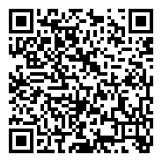
School (Ms. Chao Yu-Ying, Secretary) ：
- Complete the Survey of international students after graduation:
(Submitted PDF file of thesis (with watermark and security), returned
books and other matters affairs).

Chairman of SNHS (Professor Shih-Min Hsia)：
□ Submit forms (for master’s program)

Administrative instructor (Professor Chang Jung-Su )：

Please complete the Department Graduation Procedure first, after this form has been fully signed, the administrative instructor will signed University’s Graduation Procedure Application Form.

~Congratulations on your graduation~

